BELLRINGER – WEDNESDAY 09/21
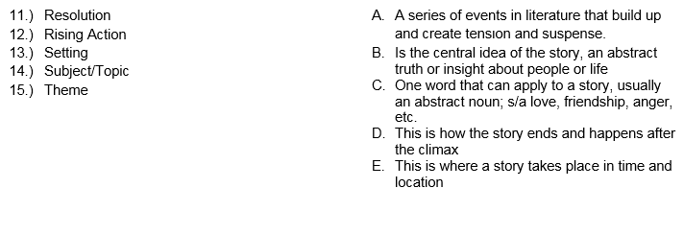

BELLRINGER – WEDNESDAY 09/21

BELLRINGER – WEDNESDAY 09/21

